The Chairman of Sevenoaks District Council
Councillor Diana Esler
invites you to join her at her charity fundraiser
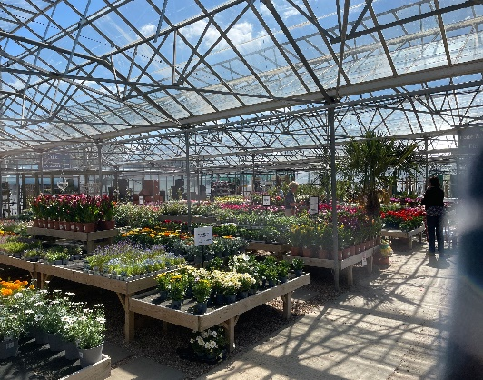
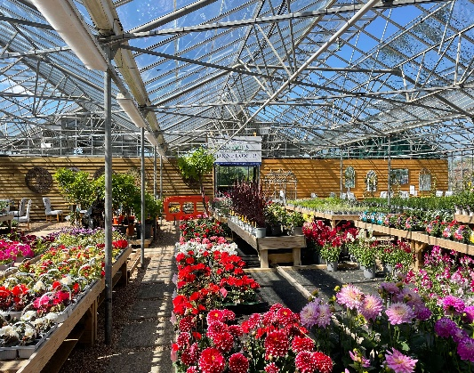
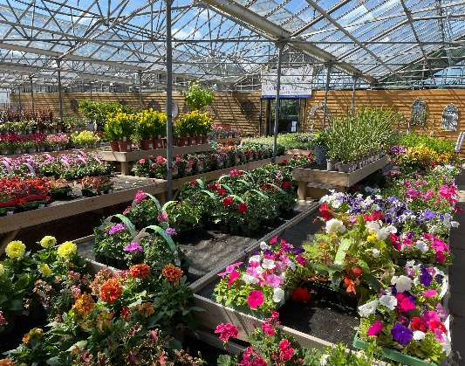
Autumnalia

At Coblands Garden Centre, Dryhill Lane, Sevenoaks TN14 6AA, Wednesday 13th October from 2 pm to 5 pm.
The Chairman would be delighted for you to join her in discovering how Coblands Garden Centre has evolved. Tim Evans, Director, and Judith Kerr-Sheppard, Centre Manager, will be explaining where plants come from (“from seeds….” may not always be the answer!). Some audience participation has been planned! A welcome glass of bubbly will precede a walk around the Centre. High Tea will be served, during which Tim and Judith will take the floor for a talk with a difference.
Dress Code: Smart Casual.
Chains/Badges of Office may be worn.
Cost: £22.50 pp.
Chauffeur/Sergeant refreshments at £10 per head.
RSVP by 4th October 2021 using the RSVP form. Payment details are on the form.
RSVP form
Name and Title of guest(s):

Chauffeur/Sergeant

-----------------
Number of tickets
------------------
Email Address

Any other special requirements? (Dietary requirements, Disabled Parking, Wheelchair access?

------------------
Payment Details:
BACS: Reference: CHEVNT 29 - Coblands
Sort Code: 20 – 76 - 63
Account Number: 60692026
Cheques payable to: Sevenoaks District Council (Chairman)
Democratic Services, Sevenoaks District Council, Argyle Road, Sevenoaks, Kent, TN13 1HG
T: 01732 227247
E: chairman@sevenoaks.gov.uk

