The Chairman of Sevenoaks District Council
Councillor Diana Esler
invites you to join her at her charity fundraiser
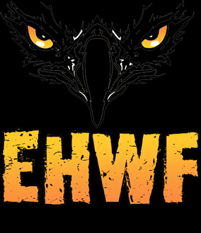
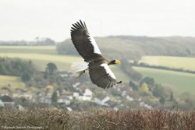
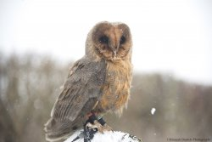
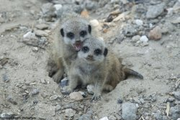
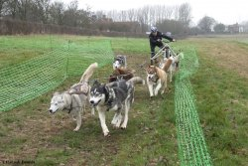
“Feathers and Furs”
To be held at the Eagle Heights Wildlife Foundation
at Lullingstone Lane, Eynsford, DA4 0JB
on Thursday 7th October 2021 at 12.30pm to 4:30pm.

The Chairman would be delighted if you would join her for a “Feathers and Furs” experience at the Eagle Heights Wildlife Foundation. A truly unique experience of watching native birds of prey demonstrate their unique flying skills. Not only does the EHWF have an eclectic range of birds of prey, they also look after a range of other exotic animals including a number of Huskies which are used on the much-booked Husky Hike. After being welcomed by the Chairman, the ethos of the Foundation will be explained by the Foundation Director.

A Cream Tea will follow the Flying Display, which will be held in a specially built area if the weather is not good. After the refreshments, you will be free to walk around the site and see animals and birds at your leisure.

This afternoon of delight starts at 12:30pm with a Welcome glass of bubbly, followed by the Flying Display and then the Cream Tea. The formal part of the afternoon finishes at 3:30pm for those who wish to leave. Carriages at 4:30pm.

Dress Code: Smart Casual and sturdy walking shoes.
Chains/Badges of Office may be worn.
Cost: £30.00pp. BACS or cheque (details below) please.
RSVP by 27th September 2021 using the attached reply form.
Chauffeur/Sergeant provision at £8pp.
RSVP form
Name and Title of guest(s):

Chauffeur/Sergeant

-----------------
Number of tickets

------------------
Any other special requirement? (Dietary requirements, Disabled Parking, Wheelchair access?

------------------
Payment Details:
BACS: Reference: CHEVNT 35 - Eagle
Sort Code: 20 – 76 - 63
Account Number: 60692026
Cheques payable to: Sevenoaks District Council (Chairman)
Democratic Services, Sevenoaks District Council, Argyle Road, Sevenoaks, Kent, TN13 1HG
T: 01732 227247
E: chairman@sevenoaks.gov.uk

